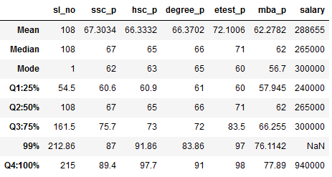

In summary, the dataset contains academic performance data for a group of individuals, and in each category (10th grade, 12th grade, degree, MBA), the mean, median, and mode suggest that the individuals' performance is generally above average. Additionally, the entrance exam marks are characterized as "good," implying strong performance on this particular assessment. This dataset reflects a group of individuals with strong academic records, especially in their 10th, 12th, degree, and MBA qualifications. Salary has outlier that we can clearly known it from this analysis.  
 1. 10th pass mark analysis percentile:

The dataset contains percentile values from 25% to 50% is increment in 6.4 values. The percentile is only from 50% to 75% is increment in 8.7 values. The percentile is only from 75% to 100% is increment in 13.7 values.

2. 12th pass mark analysis percentile:

The dataset contains percentile values from 25% to 50% is increment in 4.1 values. The percentile is only from 50% to 75% is increment in 8 values. The percentile is only from 75% to 100% is increment in 24.7 values.

3.Degree pass mark analysis percentile:

The dataset contains percentile values from 25% to 50% is increment in 5 values. The percentile is only from 50% to 75% is increment in 6 values. The percentile is only from 75% to 100% is increment in 19 values.

4.Entrance pass mark analysis percentile:

The dataset contains percentile values from 25% to 50% is increment in 11 values. The percentile is only from 50% to 75% is increment in 12.5 values. The percentile is only from 75% to 100% is increment in 14.5 values.

5.MBA pass mark analysis percentile:

The dataset contains percentile values from 25% to 50% is increment in 1.24 values. The percentile is only from 50% to 75% is increment in 4.05 values. The percentile is only from 75% to 100% is increment in 11.64 values.

6. Salary analysis percentile:

The dataset contains percentile values from 25% to 50% is increment in 25000 values. The percentile is only from 50% to 75% is increment in 35000 values. The percentile is only from 75% to 100% is increment in 64000 values.

Finally we got that last Quarter increment value is high when compared to others.